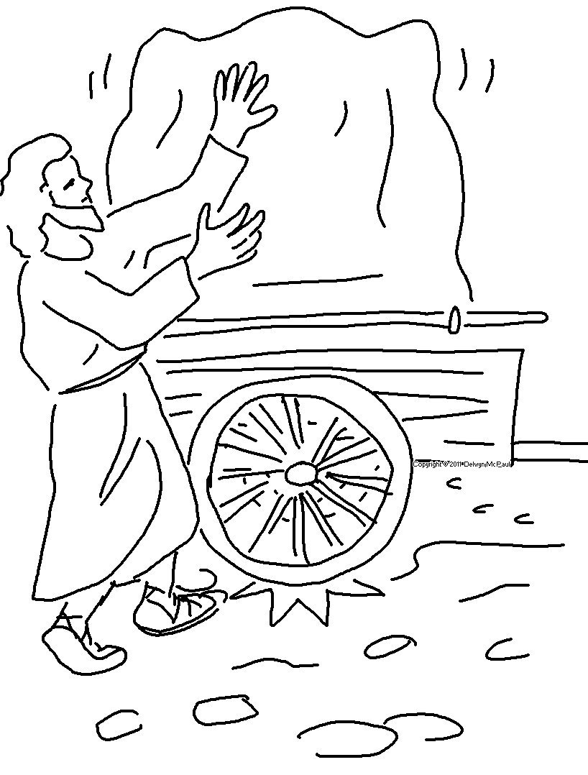

Lead me by your _ _ _ _ _ and _ _ _ _ _ me,
for you are the God who _ _ _ _ _ me.
Psalms 25:5_{NLT}

